**‘’A STUDY ON PRODUTION AND OPERATIONS REPORT ON SUGAR MILL ,KACHIRAPALAYAM’’**

An Internship submitted to

**THANTHAI HANS ROEVER COLLEGE (Autonomous), Perambalur.**

In partial fulfillment of the requirement for the award to the Degree of

**MASTER OF BUSINESS ADMINISTRATION**

Submitted By

**R.PERIYASAMY**

**(Reg.No:23PMS055)**

Under the guidance of

**Dr.M.VANEEDHARAN**

**Assistant professor in Management studies**



**PG & RESEARCH DEPARTMENT OF MANAGEMENT STUDIES**

**THANTHAI HANS ROEVER COLLEGE (Autonomous), Perambalur.**

**(Re- Accredited with B++ Grade by NAAC Affiliated to Bharathidasan University, Tiruchirappalli)**

**Elambalur, Perambalur -621212**

**March – 2024**

**DECLARATION**

I hereby declare that the Internship entitled“**A STUDY ON PRODUCTION AND OPERATIONS REPORT ON SUGAR MILL, KACHIRAPALAIYAM”**is bonafide records done by STUDENT_NAME (**Reg.No.23PMS050)** submitted to Thanthai Hans Roever College (Autonomous), Perambalur, in partial requirements for the award of the degree of **MASTER OF BUSINESS ADMINISTRATION** is a record of original work done by me during the course of study in Thanthai Hans Roever college (Autonomous), Perambalur under the Guidance of **Dr.M.VANEEDHARAN,** Assistant professor in Management Studies, Thanthai Hans Roever college (Autonomous), Perambalur.

**Signature of the candidate**

**(R.PERIYASAMY)**

**(Reg. No.23PMS055)**

**CONFIRMATION LETTER FROM THE COMPANY**

**COMPLETION CERTIFICATE FROM THE COMPANY**

**THANTHAI HANS ROEVER COLLEGE (Autonomous), Perambalur**

**(Re- Accredited with B++Grade by NAAC Affiliated to Bharathidasan University, Tiruchirappalli)**

**Elambalur, Perambalur -621220**

**PG AND RESEARCH DEPARTMENT OF MANAGEMENT STUDIES**



|  |
| --- |
| **BONAFIDE CERTIFICATE** |

This is to certify the project entitled**“A STUDY ON** **PRODUCTION AND OPERATIONS REPORT ON SUGAR MILL , KACHIRAPALAIYAM”**is bonafide record done by **R.PERIYASAMY (Reg.No. 23PMS055)** Submitted in partial fulfillment of requirements for the award of the Degree of **MASTER OF BUSINESS ADMINISTRATION** during 2023 – 2024.

**Signature of the Guide Signature of Head of the Department**

**Date of Viva-Voce External Examiners**

**ACKNOWLEDGEMENT**

I am extremely thankful to the **“THANTHAI HANS ROEVER COLLEGE(AUTONOMOUS**)” for providing golden opportunity to do this Internship.

I express my heartfelt gratitude and thanks to **Dr. K.VARADHARAAJEN, B.A., B.L.,** Founder and Chairman of Thanthai Hans Roever Educational Institutions, Perambalur.

I am deeply indebted to our principal **Dr.M.JAYANTHI, MSc.,M.Phil.,Ph.D.** has granted permission for doing this project.

My Sincere thanks to our Guide **Dr.M.VANEEDHARAN,** Assistant Professor Department ofManagement Studies for her valuable suggestions and guidance.I thank her whole heartedly her constant support extended to me.

I would also convey my sincere thanks to **----------------------------------------** Manager and all respondents for providing valuable data and all necessary information.

I thank my parents, and my friends and everyone who have helped me to complete my internship successfully.

**PLACE:**

**DATE:**

**(PERIYASAMY .R)**

**LIST OF CONTENTS**

|  |  |  |
| --- | --- | --- |
| **CHAPTER NO** | **TITLE** | **PAGE NO** |
|  | **DECLARATION** | **I** |
|  | **CONFIRMATION CERTIFICATE** | **II** |
|  | **COMPLETION CERTIFICATE** | **III** |
|  | **ACKNOWLEDGEMENT** | **IV** |
| **I** | **INTRODUCTION** |  |
|  | 1.1 Introduction to the topic |  |
|  | 1.2 Company Profile |  |
|  | 1.3 Objectives |  |
| **II** | **LITERATURE REVIEW** |  |
| **III** | **OUTCOME OF THE LEARNING** |  |
| **IV** | **FINDINGS** |  |
| **V** | **RECOMMENDATIONS AND SUGGESTIONS** |  |
| **VI** | **CONCLUSION** |  |

**I INTRODUCTION**

‘’The government is considering a mechanism to enforce and verify stock declaration of [sugar](https://www.thehindubusinessline.com/topic/sugar/) by mills, stockists and wholesalers to ensure sufficient availability through the year in coordination with the States amid expectations for [lower production](https://www.thehindubusinessline.com/economy/agri-business/india-may-miss-29-mt-sugar-output-target-on-lower-recovery-less-sugarcane/article67543991.ece), though this will be more than consumption.

“Though the Order was issued two months back, there was inadequate follow-up with the state governments. Similar to the wheat stock holding limit, states will be roped in to ensure proper verification of data submitted by stockists and wholesalers,” a senior official said.

According to the format shared, the mill has to furnish each buyer’s purchased quantity month-wise, along with PAN, GST and mobile number. However, the plan is to make self-declaration on either weekly or fortnightly basis on a designated portal, sources said.

[India’s 2023/24 sugar supply might not meet domestic demand - USDA](https://www.thehindubusinessline.com/economy/agri-business/indias-202324-sugar-supply-might-not-meet-domestic-demand-usda/article67383001.ece)

According to government estimates, domestic consumption is likely to be 27.5-28 million tonnes (mt), against production of 29-30 mt, leaving a surplus of 1.5-2 mt in the current sugar season (October-September). The opening stock as on October 1 from last year’s carry-over was 5.7 mt, and the next season’s opening stock will be around 7 mt.

However, industry experts said much will depend on how much sugar is diverted for ethanol and how much export is allowed to friendly countries on diplomatic request. “Most mills have not started making ethanol from sugarcane juice as they await the declaration of a new price for the 2023-24 ethanol supply year (November-October),” an industry official said .

The government has said there are [no plans to allow export of sugar in the 2023-24 season](https://www.thehindubusinessline.com/economy/agri-business/centre-extends-curbs-on-sugar-exports-as-dgft-notifies-shipments-policy/article67434244.ece) due to the tight supply situation. India had exported 6.1 mt of sugar in the 2022-23 season through permits issued to mills. Sugar export is only allowed with permits issued by the Food Ministry.

**1.1 Introduction to the topic**

Kallakurichi II CSM Ltd (hereafter being referred to as project proponent or simply as industry or KCSML) is an existing sugar mill located in village Kachirayapalayam falling in Taluka Chinnasalem of Villupuram district in Tamilnadu state. KCSML is a registed unit under cooperative society’s act . It is an existing 2500 TCD capacity sugar mill producing 7500 MT/month white crystalline sugar.

**Electrical power and steam requirement:**

**It does not produce electrical power -**

For power generation KCSML has made agreement with Tamilnadu News and Paper Mills Ltd (TNPL) to supply required electrical power and steam for KSGML operations. Under the agreement KSGML supplies bagasse generated in sugar mill operation to TNPL who utilizes same for running of high pressure boiler. Steam at high pressure is fed to two turbo-generator sets each of 3 MW capacity. Steam is first utilized to rotate the turbine of generator. Steam released at low pressure is fed to KCSML plant to fulfill its heating needs.

Under normal conditions sugar mill operation will require electrical power of 4.5 MW.

The proposed distillery will require 0.755 MW electrical power. Hence total power requirement after proposed expansion shall be 5.255 MW which will be fulfilled by existing turbines of 6 MW generation capacity.

**Dedicated Boiler and turbo-generator for proposed distillery:**

As clarified power and steam requirement of existing sugar mills is being met by TNPL. For proposed distillery PP desires to install a dedicated unit of 1 MW generation capacity. For this purpose a furnace oil fired boiler will be taken, steam from it will be used to run turbine to generate 1 MW electrical power. This will be sufficient to run the proposed distillery even if TNPL supplies fail.

**By products generation:**

Bagasse - 21000 MT/month

Press mud - 1875 MT/month, and

Molasses - 3400 MT/month

**KCSML now intends to install a 45 KLPD molasses based distillery in order to increase its productivity and profitability in addition to abating pollution.**

The Ministry of Environment and Forests (MoEF) Government of India has recently issued an EIA notification, S .O. 1533 dated 14 September 2006 notification amended in 1 December 2009 wide no. 3067. Under Environmental (Protection) Act (EPA) 1986. Prior Environmental Clearance from the EIA Authorities is mandatory for the establishment of projects/activities listed in the schedule of above notification Distillery projects are categorized under 5(g) of schedule of activities and therefore, require prior environmental clearance from the Expert appraisal committee / authority. Hence project of molasses based distillery unit is classified under schedule of activities 5(g) in category A.

Threshold limits for Distillery unit are none for all molasses based distilleries and ≥ 60 KLPD for non molasses based distilleries unit are classified under category A. These are appraised by EAC at MoEF New Delhi.

**NATURE OF PROJECT**

Kallakurchi Cooperative Sugar Mills Ltd is an agro based industry, manufacturing sugar from cane juice. Sugarcane is crushed @2500 TCD; juice so extracted is processed to obtain white crystalline sugar.

Bagasse, molasses and press mud are byproducts. Management has already made arrangement with Tamil Nadu Newsprint and Papers Ltd (TNPL) to utilize bagasse produced for generation of electricity and steam required for sugar mill. TNPL have installed two turbines of 3 MW capacity each. Total generation does not exceed 4.5 MW which is the power required to run the sugar mill. There is no export of power.

Proposed distillery will require 755 KVA electrical power at full load. This power will be available from existing set up of TNPL. In addition KCSML intends to install own power plant of 1 MW capacity.

In view of above threat to the fossil fuels, the ethanol is obvious choice to be considered for part substitution for fossil fuels gradually in future. Brazil adopted the above concept way back in 1970 and thus shown us the path to be followed. Initially, Brazil started with a blend of 10% ethanol with 90% petrol in 1975 and gradually increased it to 23% ethanol with 77% gasoline. Most automobiles in Brazil run either on hydrous alcohol (E100) or on gasohol (E25 blend), as the mixture of 25% anhydrous ethanol with gasoline is mandatory in the entire country. Since 2003, dual-fuel ethanol flex vehicles that run on any proportion of hydrous ethanol and gasoline have been gaining popularity. These have electronic sensors that detect the type of fuel and adjust the engine combustion to match, so users can choose the cheapest available fuel. Pure Petrol is not being sold at filling pumps in Brazil. The annual production of ethanol in Brazilhas exceeded 20 million liters. In addition to its domestic consumption, Brazil also exports ethanol to other countries.

**1.2 Company Profile**

Kallakurichi II CSM Ltd (hereafter being referred as KCSML or simply as industry, is an existing sugar mill located in Kachirayapalayam in Taluka Chinnasalem in district Villupuram Tamilnadu 606207. It is an existing 2500 TCD sugar mill. Kallakurichi II CSM Ltd has about 100 acres of land for its manufacturing activities.

Letter of intent for installation of 2500 TCD capacity Sugar Mill under cooperative sector in Kachirayapalayam was issued by Government of India vide LOI No. 254(90). Accordingly, Kallakurichi – II Co- operative Sugar mills Ltd Kachirayapalayam has been proposed to be set- up for sugar production in Chinnasalem Taluk of Villupuram District in Tamilnadu.

The Sugar mill is registered by Commissioner of Sugar and Registrar of Coop. Societies of sugar mills on 01.10.1990 under Tamil nadu Co-op. Societies Act 1983. Industrial License was received by the mill vide letter No. F22/(434)/92/ST/8, dt. 1.01.2000. The total share capital of the mills, as on 31.03.2014, is Rs. 3488.46 Lakhs which is inclusive of Rs. 1332.50 Lakhs invested by Government of Tamilnadu.

The balance Rs. 2155.96 lakhs is the share capital invested by cane growers (Including Non Refundable Deposit share capital of Rs. 489.28 lakhs). The Sugar mill obtained ISO 9001-2008 Certificate from International Services (ICS), Mumbai on 03.02.2006 bearing Registration Number RQ91/3953, Dated 03.02.2006.

**Consent for operation**

The exting company has been isued consent order number 12672 on 8-5- 1998 under section 21 of air (prevention and control of pollution) Act afterword is been reviewed with lates renewal valied upto 31 th march 2015.

The exting company also has been isued consent order number 2589 on 28-7-2004 for disposal of hazardous waste under rule 3 (c) and 5 (5) of hazardous waste management and handling rule and its ammendment in 2000.

The exting company has been isued consent order number 16552 on 8-5- 1998 under section 25 of water (prevention and control of pollution) Act 1974 afterword is been reviewed with latest renewal valied upto 31 th march 2015.

**Management**

Kallakurichi – II Co-operative Sugar mills Ltd has a team of dynamic and progressive members in the Management Board. Under their leadership the sugar mill is functioning well and achieving its goals. The Suger Mill, under the leadership of Mr. K. Kanagasundram, Managing Director has progressed consistently and looks ahead for still better performance in years to come.

**Future vision**

During setting up of Sugar mill, the management acquired an extra land for expansion/diversification in future. Accordingly, an adequate piece of land is available in Sugar mill premises which can be best suited for setting up of the proposed 45 KLPD Distillery.

Molasses and Press mud from sugar mill are presently being sold to nearby distilleries and to farmers. However by setting up of the proposed distillery, these sugar mill by- product shall be utilized as own resources in the form of feed for their distillery and shall earn extra profit due to value addition of these byproduct in the form of Alcohol and Bio-compost.

The sugar mill management has decided to put up a 45 KLPD capacity Molasses based Distillery cum Ethanol plant. The Molasses required could be met by own molasses and by the molasses produced in the nearby sister cooperative sugar mills.

By Installation of 45 KLPD Molasses based Distillery cum Ethanol plant, the mill shall utilize their by-product Molasses and Press mud in the Distillery, which will lead to value addition.

The proposed Distillery cum Ethanol plant shall generate employment opportunity to the needy people in nearby areas. Thus, Management feel proud in obliging the sons of soil by providing the jobs to these people and fulfilling the social commitments by extending the welfare amenities to their family.

The Ministry of Environment and Forests (MoEF) Government of India has issued an EIA notification, S .O. 1533 dated 14 September 2006 notification amended in 1 December 2009 wide no. 3067. Under Environmental (Protection) Act (EPA) 1986. Prior Environmental Clearance from the EIA Authorities is mandatory for the establishment of projects/activities listed in the schedule of above notification Distillery projects are categorized under 5(g) of schedule of activities and therefore, require prior environmental clearance from the Expert appraisal committee / authority. Hence project of Kallakurchi-II CSML molasses based distillery unit is classified under **5(g) category A.**

**1.3 Objectives**

The Government of India (GOI) approved the National Policy on Bio-fuels on December 24, 2009. The policy encourages use of renewable energy resources as alternate fuel to supplement transport fuels and had proposed an indicative target to replace 20% of petroleum fuel consumption with bio-fuels (bio-ethanol and biodiesel) by end of 12th Five- Year Plan (2017) in a bid to renew its focus and strongly implement the Ethanol Blending Program (EBP), the Cabinet Committee of Economic Affairs (CCEA) on Nov 22, 2012, recommended 5% mandatory blending of ethanol with gasoline. It has also recommended that the procurement price of ethanol shall now be decided by between the Oil Marketing Companies (mostly PSU) and suppliers of ethanol. The government’s current target of 5% blending of ethanol in gasoline has been partially successful in years of surplus sugar production and not fulfilled when sugar production declines.

|  |  |  |
| --- | --- | --- |
| **Sr.No** | **Feature** | **Particculars** |
| **1.** | **Products** | **Fuel Ethanol – 45KLPD**  **ENA _45KLPD**  **Impure Spirit_45KLPD** |
| **2.** | **Byproduct** | **Biogas _14040 nm3/day**  **Bio-compost _41.93MT/day** |

**TYPE OF PROJECT**

**INTERLINKED PROJECT**

|  |  |  |
| --- | --- | --- |
| **Sr.No** | **Feature** | **Particculars** |
| **1.** | **Products** | **Sugar - 2500 TCD 4.** |
| **2.** | **Byproduct** | **Molasses – 100MT/day**  **Bagasse _750MT/day**  **Press mud - 100 MT/day** |

**SITE LOCATION**

The Distillery project including Bio-Methanation plant will require land for entire basic infrastructure. Plant equipments, storage of plant inputs and finished products. Besides this Administrative Office, Security arrangements, Fire fighting arrangements etc shall also have to be considered. Plant layout is prepared keeping in view, the above composition of project.

It shall be accommodated in a plot size of approx. 14.50 Acres.

|  |  |  |
| --- | --- | --- |
| Sr.No. | Feacture | Particulars |
| 1. | Location | Kallakuchi II CSM Ltd Kachirayapalayam Chinnasalem Villupuram Tamilnadu – 606 207 |
| 2. | Latitude  Longitude | 11° 45' 29.85" N  78° 52' 24.07" E |
| 3. | Nearest Highway | NH-68 |
| 4. | Nearest village | Kachirayapalayam |
| 5. | Nearest Railway station | Chinnasalem |
| 6. | Nearest Airport | Salem |
| 7. | Nearest Town | Kallakurichi |

MANGNITUDE OF OPERATION:

Following table clearly indicates all facets of proposed project to elaborate

magnitude of project:

|  |  |  |
| --- | --- | --- |
| Sr.No. | Feature | Details |
| 1. | Area State,emt* |  |
|  | Total plot area | 412500 M2 |
| 2. | Working days | 300 |
|  | Season | 150 |
|  | Off-season | 150 |
| 3. | Products |  |
|  | ENA | 45 KLPD |
|  | IS | 2.25 KLPD |
|  | Fuel Ethanol | 45 KLPD |
|  | By product |  |
|  | Biocompost | 41.93 MT/day |
|  | Biogas | 14040 Nm3/day |
| 4. | Water sources |  |
|  | Well water | Pottiyam village |
|  | Fresh water required | 641 m3/day |
| 5. | Power requifrement | 755 KVA |
| 6. | Back up power | 750 KVA |
|  | D G set rating | 750 KVA |
|  | Fuel used | HFO |
|  | Power consumption | 755 KW |
| 7. | Man power | 51 Nos. |
|  | Staff | 7 Nos. |
|  | Workers | 26 Nos. |
|  | Contractual labor | 18 Nos. |
| Total Investment | | Rs.9000 lakhs |

Investment :

|  |  |  |
| --- | --- | --- |
| Sr . No . | Particulars | Amount Rs in Lakhs |
| 1 | Total project Cost | 9000.00 |
| 2 | Own Funds @ 10% | 900.00 |
| 3 | Loan from sugar Development fund @ 40% | 3600.00 |
| 4 | Loan from National coop. Development corporation @ 50% | 4500.00 |

**ENVIRIONMENTAL MANAGEMENT PLAN**

Ours is an existing industry planning new unit and we have well established environmental management plan (EMP). The distillery, sugar plant and power plant utilize resource such as water, cane sugar, bagasse etc. and discharge liquid, gaseous and solid waste products. Mitigation measures are incorporated in the project to protect environment against any harm. A comprehensive

environmental management plan is adopted consisting of proposed pollution

control measures and additional mitigation measures for abatement undesirable

impacts. Summary of these measures includes:

1. Green belt and greenery development in the factory premises.

2. Waste water management Recycle & Reuse of condensate

3. Paving and lining of roads, solid storage yards of ash etc.

4. Self monitoring system is established in the industry with man power and

facilities to ascertain the compliances of environmental norms and

standards.

5. Personal health care program, emergency management plan and safety

management systems will be implemented in the distillery.

6. Operation and Maintenance of pollution control measures

7. Establishment of waste reduction measure.

BUDGET ALLOCATION FOR EMP

|  |  |  |  |  |
| --- | --- | --- | --- | --- |
| Sr . No . | Particular | Copital cost | Annual recurring cost | |
| Rupees in lacs. | | |
| 1. | 48 M high chimney | 88 | | 4 |
| 2. | Water pollution control equipment including R O filter and bio-digester for zero discharger | 350 | | 28 |
| 3. | Compost yard | 250 | | 26 |
| 4. | Composting equipments | 78 | | 18 |
| 5. | Spent wash storage tank | 250 | | 14 |
| 6. | Montioring of pollution parameters | --- | | 5 |
| 7. | Laboratiory and chemicals | 5 | | 4 |
| 8. | Safety and healthcare | 3 | | 1 |
| 9. | Operation and maintenance | -- | | 10 |
| 10. | Salary of EVP staff | -- | | 36 |
| 11. | Development of green belt | 12 | | 3 |
| Total | | 1036 | | 149 |

The industry on expansion will provide direct and indirect employment to many

local rural persons. In addition the manure / compost containing extra rich soil

nutrients like nitrogen, potassium and phosphorus will be generated giving a

boost to the agricultural produce of local farmers thus contributing to overall

prosperity of the region. The project will be a boon as power will be fed to grid for

other users in a power deficit state as is ours.

**ll LITERATURE REVIEW**

Sugarcane has enhanced its status from an unknown wild grass plant to the world’s largest cultivated cash crop with its incredible ability to synthesize and accumulate sucrose in its stem. Sugarcane domestication was started around 8000 BC in the region of New Guinea and later it reached Southeast Asia and India. During fifth century AD, a novel strategy for crystallization of sugar was invented by an Indian scientist who facilitated the storage and transportation of crystallized sugar substances easier. Following this invention, the process of sugarcane cultivation, refining sugarcane juice and production of granulated sugar was spread to China, Persia and the Mediterranean regions. Sugarcane has started spreading across the Asia, Europe and Arab nations where people started to cultivate sugarcane, especially after they conquered Egypt. Sugarcane has reached Spain around 715 AD and certain countries (Spain, Portugal, Italy, Cyprus and Azores) have tried to stabilize their economy using sugarcane production during sixteenth and seventeenth centuries. As the New World has offered better climatic conditions for the growth and better productivity, sugarcane varieties were also quickly introduced in the United States .

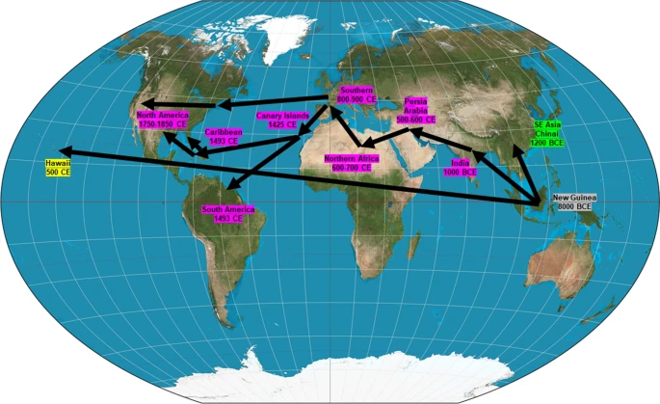

Timeline of the anthropogenic intercontinental distribution of sugarcane. The major distribution routes were through India, then to the Middle East, Africa, Europe and finally to the Americas

Sugarcane belongs to the genus Saccharum, family Poaceae with the tribe Andropogoneae. Genera such as Miscanthus, Sclerostachya, Erianthus, Narenga, and Saccharum are closely related and forming the Saccharum complex. However, S. officinarum is the original sugarcane species and is supposed to have originated in the Indonesian Archipelago (Fig. 1). The species does not occur in the natural wild conditions but was grown and maintained for a long time by the island natives. The colonial Dutch workers have called S. officinarum as the ‘noble cane’ as it was used as the main source material for sugar production. The process of crossing and back-crossing was designed towards the development of hardy and disease resistance traits with sweeter noble canes is termed as ‘nobilization’ (Stevenson 1965). Present day sugarcane is a man-made hybrid clone produced from S. officinarum, and S. spontaneum with a few genes incorporated from S. barberi, and S. sinense and to a limited extent from S. robustum.

* *Saccharum spontaneum* is a polymorphic wild grass distributed in the tropics and sub tropics (Panje and Babu [1960](https://link.springer.com/article/10.1007/s10722-022-01430-6#ref-CR77))
* *Saccharum robustum* is a tall and thick canes spread in riverbanks of New Guinea and Indonesia (Mukherjee [1957](https://link.springer.com/article/10.1007/s10722-022-01430-6#ref-CR70))
* *Saccharum officinarum*, the noble sugarcane, is present only under domesticated conditions in New Guinea and Indonesia (Parthasarathy [1948](https://link.springer.com/article/10.1007/s10722-022-01430-6#ref-CR80))
* *Saccharum barberi* Jesw. and *S. sinense* Roxb. are North Indian and Chinese canes that were under cultivation for sugar production, and are believed to be produced from interspecific crosses between *S. officinarum* and local varieties of *S. spontaneum* (D’Hont et al. [2002](https://link.springer.com/article/10.1007/s10722-022-01430-6#ref-CR18)). More recently, *S. barberi* and *S. sinense* are considered as single species with S, sinense as acccepted name and *S. barberi* as a synonym (World Flora online).
* *Saccharum edule* Hassk. is a polymorphic species with aneuploidy and is cultivated in the Pacific islands for its aborted inflorescence, which is used as a vegetable. The cane of *S. edule* resembles that of *S. robustum*, and is a natural hybrid involving *S. robustum, S. officinarum* and *Miscanthus* spp (Roach [1972](https://link.springer.com/article/10.1007/s10722-022-01430-6#ref-CR89)). However, in the recent years *S. edule* has been identified as *S. spontaneum* var. edulis (Hassk.) K.Schum. (World Flora online). *S. officinarum* is evolutionarily derived from the three groups of *S. robustum*, namely Red fleshed, Port Moresby and Teboe Salah, which are again evolved through interspecific introgression between *S. spontaneum, S. arundinaceum* Retz. and *M. sinensis* (Daniels J and Roach BT [1987](https://link.springer.com/article/10.1007/s10722-022-01430-6#ref-CR22); Daniels, J et al. [1989](https://link.springer.com/article/10.1007/s10722-022-01430-6#ref-CR21)). It is hypothesized that *S. officinarum* is anthropogenically selected from *S. robustum* in New Guinea, as a sweeter chewing plant in riverbanks and lowlands or as a sweeter fencing plant in highlands or as a plant that was selectively damaged by rats and pigs for its sweetness, which drew human attention .

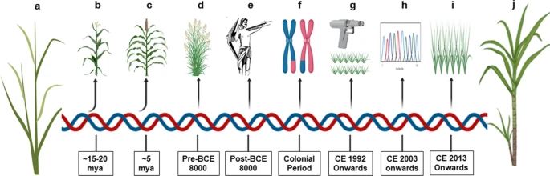

Timeline of sugarcane. **a**. Progenitor grass species. **b**. Evolutionary split of maize. **c**. Evolutionary split of sorghum. **d**. Genus *Saccharum* pre-domestication. **e**. Selection and domestication. **f**. Breeding and improvement. **g**. Transgenic development. **h**. Omics research. **i.** market release of transgenic sugarcane. **j**. sugarcane with better traits

ugarcane is a cross-pollinated crop with negligible selfing. Even though sugarcane flowers have reduced male fertility, they are rarely male sterile. Sugarcane pollens are very small with a half-life of just 12 min. They become non-viable beyond 35 min, when exposed to 26° C and 67% relative humidity (Moore 1976). Therefore, viable pollens are not expected to travel faraway in the field. However, they can be stored at a reduced temperature and increased relative humidity, where they retain some viability for up to 14 days. The flowering behavior of sugarcane is considerably significant for breeders to develop new varieties, whereas it is not a favorable character for farmers (Jeswiet J [1925](https://link.springer.com/article/10.1007/s10722-022-01430-6#ref-CR50)).

**Plaantation White sugar manufacturing Process:**

Harvested ripened clean cane is transported to cane weigh bridge by growers and weighed. The weighed cane is dumped in the cane carrier. The cane is prepared and sent milling Tandem, there it is crushed with imbibition water by the mills and the juice extracted is called mixed juice, mixed juice is pumped to sugar manufacturing process. The residue after extraction of juice is called bagasse and dispatched to TNPL for making paper.

It is being weighed by Automatic juice weighing scale. The weighed juice is sent through juice heaters for heating. After addition of milk of lime and SO, it is heated and sent to clarifier for settling. In clarifier mud is settled and the decanted juice is called clear juice. The mud from the clarifier sent to the vacuum filter, there it is filtered, filter cake is sent out and it is used by the farmers as manure. The filtrate juice is again taken for process. Clear juice is thickened in the Evaporators and denser syrup is sulphited and sent to pan floor for making sugar.

In vacuum pan boiling different size crystals are developed and called as A, B & C massecuites. The above massecuites are boiled in pans and dropped in crystallizers. Crystallisation of sugar takes place in pans and crystallizers. The sugar crystal is being developed by absorption of sugar in the syrup and other mother liquors. The massecuites are taken to centrifugals called A, B & C centrifugals, there the molasses and sugar crystals are separated out. The sugar crystals coming out from 'A' centrifugal is dried in the hoppers and graded. After grading of sugar, it is sent to sugar Bins. The final molasses coming out of C-Centrifugal is sent to steel molasses tank and stored.

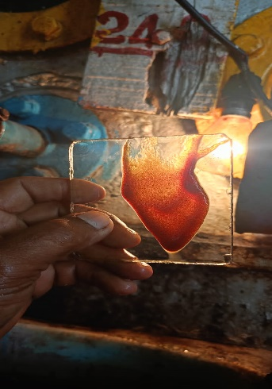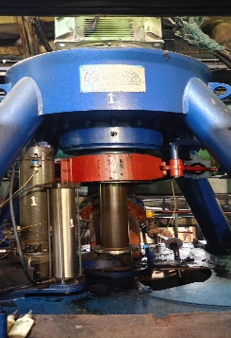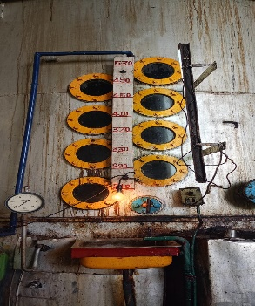



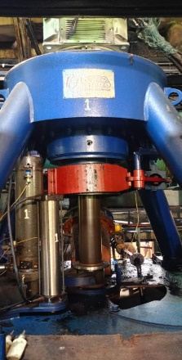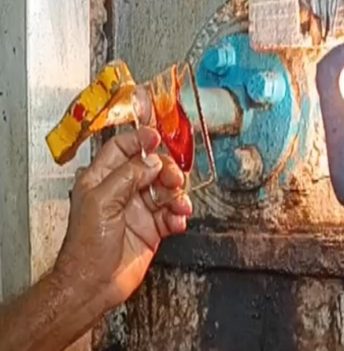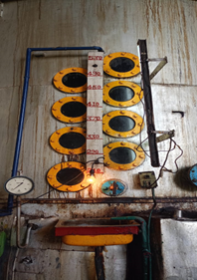

(B)

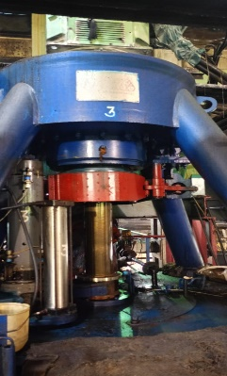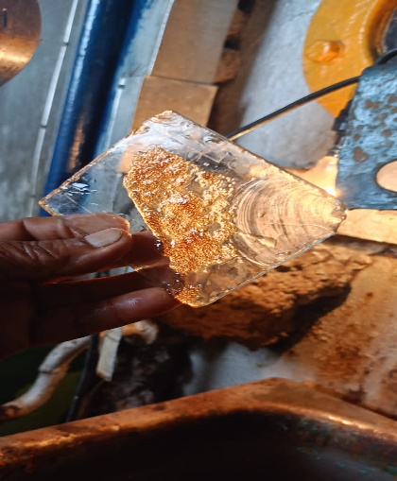



aaaaas

(c)

Sugar from the sugar Bins are bagged in gunnies by Auto Sugar Bags Weighing Machines, stitched and sent to Godown for stacking.

**III OUTCOME OF THE LEARNING**

Learning outcomes are statements of the knowledge, skills and abilities individual students should possess and can demonstrate upon completion of a learning experience or sequence of learning experiences.

Training has an important role to play and it is expected to inculcate positive changes in knowledge, skills and attitudes. . All organisations employing people need to train and develop their staff. Most organisations are cognisant of this requirement and invest effort and other resources in training and development.Employees training tries to improve skills so that employee is better equipped to do his present job or to prepare him for a higher position with increased responsibilities. Organizations should provide opportunities for continuous development of employees not only in their present jobs but also to develop the capabilities for other jobs also.

Training and Development programmes are necessary in any organization for improving the quality of work of the employees at all level. Training and development play an important role in the effectiveness of organisations and to the experiences of people in work. Training has implications for productivity, health and safety at work and personal development Such investment can take the form of employing specialist training and development staff and paying alaries to staff undergoing training and development. Investment in training and development entails obtaining and maintaining space and equipment My Paper is based on employees training requirement in the Private sector sugar mills and its impact on the employees as well as on the organisation. Key words: Training and development,employees efficiency,organisation growth,Job satisfaction.

IV FINDINGS

The Indian potable alcohol market can be classified into “Country liquor” and

“Indian-Made Foreign Liquor” (IMFL) which account for the bulk of alcohol

utilization in the country. The potable alcohol industry is estimated at a market

value of approximately Rs. 300 billion and has been growing at the rate of 7-10

percent/ annum over the past few years. However, the exact shares of country

liquor and IMFL manufacturing are unknown since production of Country liquor

is still being done illegally in many areas, making it difficult to arrive at a correct

estimate.

Since, grain prices have remained quite stable compared to sugarcane-based

molasses, cost of production using grain feedstock remains quite predictable for

alcohol producers. But in general, it is more expensive to use grains unless

molasses prices are very high. Thus, establishing dual substrate facilities gives

distilleries flexibility to switch between molasses and grains according to price

changes.

The potable alcohol produced in India is primarily made from sugarcane

molasses and not from grain as in many other countries. Due to the increasing

uncertainties involved in molasses availability (and the resultant increase in its

prices) the industry is gradually accepting the option of grain-based alcohol.

However, molasses still accounts for most of the domestically produced potable alcohol in the country. The process of manufacturing IMFL (such as whisky,

rum, and brandy) includes a secondary distillation of the fermented mixture of

grains and molasses that yields extra neutral alcohol (ENA) with 94.6% alcohol

content, which is diluted to obtain IMFL. The IMFLs are usually of 42.8% v/v ethanol content. In the past few years, significant growth has been achieved in

the production of quality spirits and the industry is now exporting these

products. In terms of market players, the IMFL industry is highly consolidated

with a few companies holding significant shares in the market. The production

centers for IMFL are mostly located in the sugar-producing states of

Maharashtra, UP, Karnataka, and Tamil Nadu and some in Haryana and Punjab.

Regulation and taxation of the sector is under the jurisdiction of the state

governments and is large source of revenue for the states.

**Fuel Ethanol for Blending in Gasoline**

The Government of India (GOI) approved the National Policy on Bio-fuels on

December 24, 2009. The policy encourages use of renewable energy resources as alternate fuel to supplement transport fuels and had proposed an indicative

target to replace 20% of petroleum fuel consumption with bio-fuels (bio-ethanol

and biodiesel) by end of 12th Five- Year Plan (2017) in a bid to renew its focus

and strongly implement the Ethanol Blending Program (EBP), the Cabinet

Committee of Economic Affairs (CCEA) on Nov 22, 2012, recommended 5% mandatory blending of ethanol with gasoline. It has also recommended that the

procurement price of ethanol shall now be decided by between the Oil Marketing

Companies (mostly PSU) and suppliers of ethanol. The government’s current

target of 5% blending of ethanol in gasoline has been partially successful in

years of surplus sugar production and not fulfilled when sugar production

decline.

EMPLOYMENT GENERATION:

Employment generation by existing sugar mills and proposed distillery is detailed

below:

|  |  |  |
| --- | --- | --- |
| Employment Description | Sugar Mill  No.of Employees | Proposed Distillery  No . of Employees |
| Skilled & Unskilled Workers | 55 | 26 |
| Staff | 87 | 7 |
| Officers | 16 | -- |
| Casuals | 142 | 18 |
| Total | 282 | 51 |

Type of project

The proposed project is having capacity of 45 KLPD with molasses as raw

material.

|  |  |  |
| --- | --- | --- |
| Sr . No. | Feature | Particulars |
|  | Products | Fuel Ethanol -45 KLPD  ENA -45 KLPD  Lmpure Spirit -45 KLPD |
| 2. | Byproduct | Power - 1.0 MW  Biogas – 14040 nm3/day  Bio-compost – 41.93 MT/day |

**V RECOMMENDATIONS AND SUGGESTIONS**

[**The difference between suggestion and recommendation is**](https://www.bing.com/ck/a?!&&p=1aaf55cb449bd020JmltdHM9MTcwOTg1NjAwMCZpZ3VpZD0xZGMxZDM0MS1jN2ZkLTZlM2YtM2YwNy1jMTg3YzY4YTZmYTMmaW5zaWQ9NTc3NQ&ptn=3&ver=2&hsh=3&fclid=1dc1d341-c7fd-6e3f-3f07-c187c68a6fa3&psq=difference+between+suggestion+and+recommendation&u=a1aHR0cHM6Ly9lbGwuc3RhY2tleGNoYW5nZS5jb20vcXVlc3Rpb25zLzU5MjMwL3doYXQtaXMtdGhlLWRpZmZlcmVuY2UtYmV0d2Vlbi1zdWdnZXN0aW9uLWFuZC1yZWNvbW1lbmRhdGlvbg&ntb=1)**:**

suggesting something means offering a potential solution or course of action without imposing it as the only or best choice. It is more informal and is used to express an idea or opinion.

* A recommendation is a formal or authoritative suggestion, often based on expert knowledge or experience. It implies that the person making the recommendation has carefully considered the options and is confident in their advice. It carries a stronger sense of authority and expertise.

**Define Recommendation**

For example, a friend might suggest a restaurant for dinner based on their own positive experience there. Or a coworker might suggest a new approach to a project based on their own ideas and perspective. Suggestions are often seen as less authoritative than recommendations, as they are based on a lower level of expertise and analysis. However, they can still be valuable and helpful in certain situations, particularly when they come from someone with relevant experience or knowledge.

For example, a friend might suggest a restaurant for dinner based on their own positive experience there. Or a coworker might suggest a new approach to a project based on their own ideas and perspective.

Suggestions are often seen as less authoritative than recommendations, as they are based on a lower level of expertise and analysis. However, they can still be valuable and helpful in certain situations, particularly when they come from someone with relevant experience or knowledge.

**How To Use “Recommendation” In A Sentence**

The word “recommendation” is often used to express a formal or official opinion or suggestion. It is commonly used in professional settings, such as in business or academic writing. Here are some examples of how to use “recommendation” in a sentence:

* After conducting a thorough analysis, our team has made the recommendation to invest in the new software.
* The committee’s recommendation was to reject the proposal due to insufficient evidence.
* I highly recommend this book to anyone interested in learning more about the topic.

When using “recommendation” in a sentence, it is important to consider the context and tone of the message. The word carries a sense of authority and expertise, so it is best used in situations where a formal or official opinion is needed.

**How To Use “Suggestion” In A Sentence**

The word “suggestion” is often used to express a casual or informal opinion or idea. It is commonly used in everyday conversation or in creative writing. Here are some examples of how to use “suggestion” in a sentence:

* Do you have any suggestions for where we should go for dinner?
* My suggestion is to start with the basics and work your way up to the more advanced techniques.
* The author’s suggestion that the character was based on a real person adds an interesting layer to the story.

When using “suggestion” in a sentence, it is important to consider the tone and level of formality. The word carries a sense of openness and flexibility, so it is best used in situations where a casual or informal opinion is appropriate.

**Common Mistakes**

* **Using “recommendation” when you mean “suggestion”**: A recommendation is a formal suggestion made by an expert or authority figure. Using this term when you simply mean to offer an idea or option can come across as presumptuous or overbearing.
* **Using “suggestion” when you mean “recommendation”**: On the other hand, using the term “suggestion” when you actually mean to recommend something can make your advice seem less important or valuable.
* **Assuming that “recommendation” and “suggestion” are interchangeable**: While these two words may seem similar, they have distinct meanings and should be used appropriately. Failing to recognize this can lead to confusion and miscommunication.

**Examples Of Using Recommendation In A Sentence**

* The doctor’s recommendation was to get at least 8 hours of sleep each night.
* I would like to make a recommendation for a good restaurant in the area.
* The company’s recommendation is to invest in renewable energy sources.
* Based on my experience, I would strongly recommend this product to others.
* The committee’s recommendation was to approve the new policy.
* My recommendation is to take the scenic route to get to the destination.
* The professor’s recommendation was to read the assigned chapters before the exam.
* I received a recommendation from a friend to try this new workout program.
* The travel agent’s recommendation was to book the all-inclusive package.
* I followed the dentist’s recommendation to floss daily and my teeth have never been healthier.

**Examples Of Using Suggestion In A Sentence**

* Can I make a suggestion? Let’s try a different approach for this project.
* My suggestion is to start the meeting with a brief icebreaker activity.
* The coach’s suggestion was to focus on improving our defense during practice.
* After reviewing the data, the consultant’s suggestion was to increase marketing efforts in the Midwest region.
* My friend’s suggestion was to try the new Thai restaurant down the street.
* The teacher’s suggestion was to break the class into smaller groups for the project.
* The therapist’s suggestion was to practice mindfulness meditation to reduce stress.
* One suggestion for improving the website is to make the navigation menu more user-friendly.
* The boss’s suggestion was to hold a team-building event to improve morale.
* I appreciated my coworker’s suggestion to double-check the calculations before submitting the report.

PRODUCTION PROCESS :

Process of production can be described as below:

Steps;

1.)Weighted sugarcane is brought to be grinded

2.)Mill House is that place Where sugarcane is brought to take out juice

3.) House is the place where Boiler steam is produced from water

4.)Boiling house this is the place where sugarcane jjuice is boiled and syrup is made out from it

5.)Boiling hose where from centrifugal machine syrup is prepared then from Massecuite sugar is made out of the firm

6.)Once the sugar is ready it is purified in different sieves and segregated

7.) The sugar which is purified then it is packerd in different sacks

8.)Packed sacls are then sent to the GO dawn by crane

9.) Sugar go dawn is the place where sugar sacks are store

**VI CONCLUSION**

a Conclusion The sugar manufacturing process is a **complex and time-consuming one**, involving a variety of steps and inputs. Sugar manufacturers must carefully manage these inputs to ensure high-quality products. Sugar production involves the careful selection of raw materials, the right equipment, and the right processing techniques.

a The use of resources in the Sugar industry is spatially organised by the countries that produce sugar and the countries that buy or trade  sugar. The producing countries are normally tropical countries and they are sometimes developing countries. The trade and export of sugar shows the interconnections of the world through one product. This ensures that the consumption and  use of sugar which is in demand for more production.

a Though there is consequences by the health effects and environmental effects which can lead to many serious problems.  
The interconnections of sugar is led by the framer who farm the sugarcane product, the workers that work in the refining process, the engineers and the exporters.

